Adding Transparent Text to an image

Step 1: Add A New Blank Layer
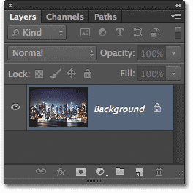
Let’s start by adding a new blank layer, which we can do by clicking the New Layer icon at the bottom of the Layers panel:
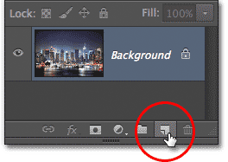
Clicking the New Layer icon.
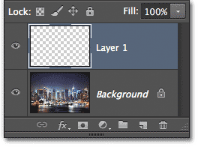
The Layers panel showing Layer 1 above the Background layer.

Step 2: Fill The New Layer With White
Let’s fill the layer with white. Go up to the Edit menu in the Menu Bar along the top of the screen and choose the Fill command:
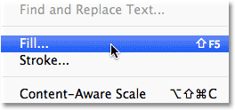
Go to Edit > Fill.
This opens the Fill dialog box. Set the Use option at the top of the dialog box to White, and make sure the Mode option at the bottom is set to Normal and Opacity is set to 100% (which they should be by default):
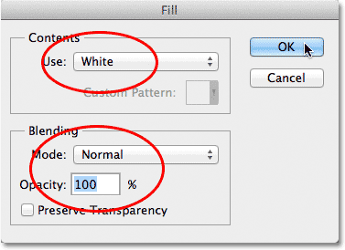
Click OK to close out of the Fill dialog box. Photoshop fills Layer 1 with white, and since Layer 1 is sitting above the Background layer, the solid white temporarily blocks the photo from view in the document window:
The document window after filling Layer 1 with white.

Step 3: Lower The Opacity Of Layer 1
You’ll find the Opacity option in the top right corner of the Layers panel. Set it to 70%:
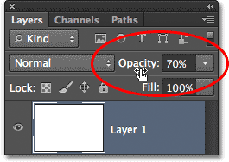
With the opacity lowered, I can now see the original photo showing through the white-filled layer:
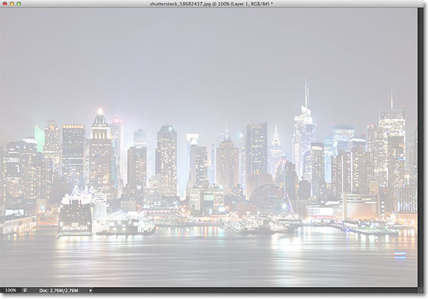

Step 4: Add Your Text
Let’s add our text. Select the Type Tool from the Tools panel:
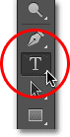
With your Type Tool selected, choose your font and font size up in the Options Bar along the top of the screen. Choose a WIDE, Thick Font.
Set the color of your type to black. If it’s not already set to black if it isn't already.
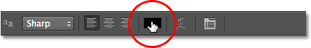
The color swatch shows the current color for the type. Click on it to choose a different color.
Type your text.
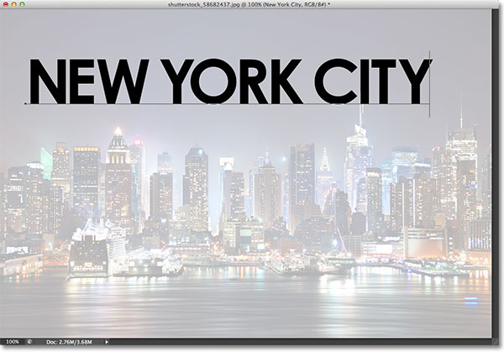
When you’re done, click the checkmark in the Options Bar to accept the text and exit out of text-editing mode:
If we look again in the Layers panel, we see our newly added Type layer sitting above our white background on Layer 1:
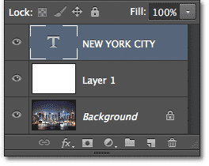

Step 5: Resize The Type With Free Transform
Go to Edit > Free Transform.

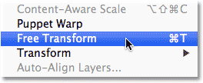
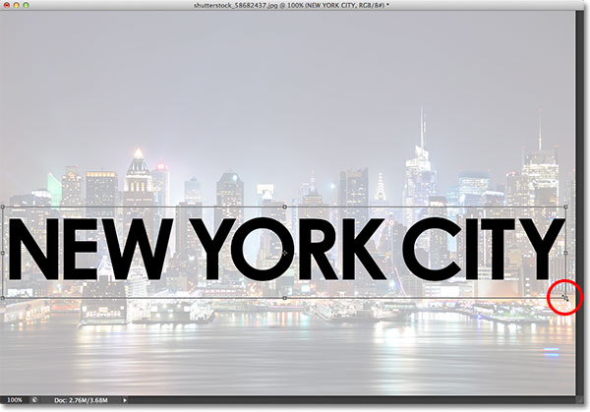
Resizing and moving the text into position with Free Transform.

Step 6: Add The Type Layer And Layer 1 To A Layer Group
Next, we need to place both the Type layer and Layer 1 below it into a layer group.
To do that, we first need to have both layers selected in the Layers panel. We already have the Type layer selected, so hold down your Shift key and click on Layer 1. This will select both layers at once (both will be highlighted in blue):
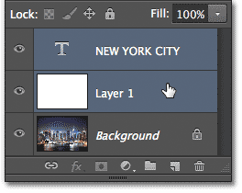
.
With both layers selected, Go to Layers > Group Layers.
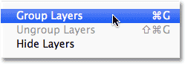

Clicking the triangle icon to open the group and see its layers.

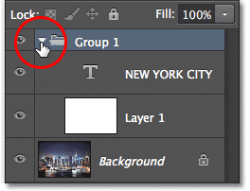

Step 7: Select The Type Layer
Click on the Type layer to select it:
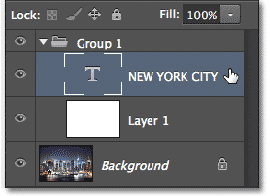

Step 8: Open The Blending Options
With the Type layer selected, click on the small menu icon in the top right corner of the Layers panel:
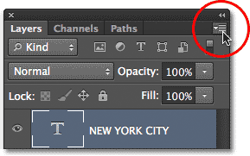
Clicking the Layers panel menu icon.
This opens a menu with various Layers panel-related options. Choose Blending Options from the list:
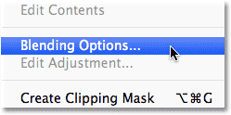
. Look for the Knockout option in the Advanced Blending section and change it from None to Shallow:
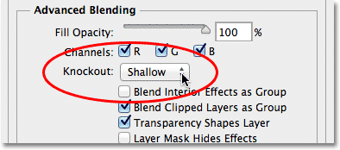
Then drag the Fill Opacity slider above it all the way to the left to set its value to 0%:
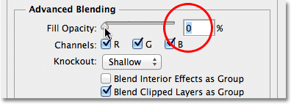
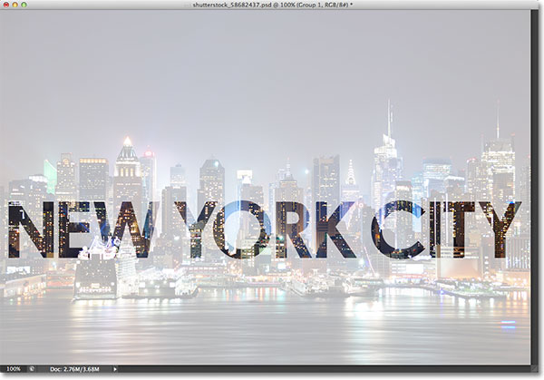
The photo on the Background layer is now visible inside the text.

Step 9: Select Layer 1
Resize layer 1 that is semi-transparent.
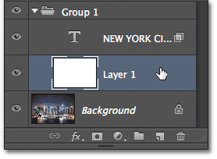

Step 10: Resize The Background With Free Transform
Go to the Edit menu at the top of the screen and choose Free Transform.

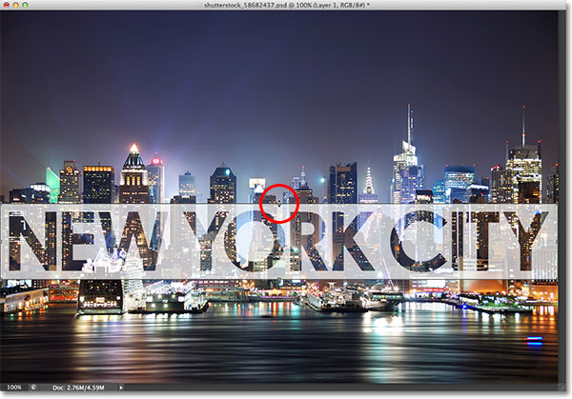
Dragging the top and bottom transform handles to reshape the background around the text.

Increasing the Opacity value to 80%. This step may NOT be necessary!

